# HTML and CSS

## **HTML Task**

1. **What is HTML? Give basic structure of the HTML page.**

* HTML stands for HYPERTEXT MARKUP LANGUAGE.
* HTML is the standard markup language for creating Web pages.
* HTML describes the structure of a Web page.
* Every web page you see was written using one version of HTML.

Basic Structure of HTML page :

<!DOCTYPE *html*>

<html *lang*="en">

<head>

    <meta *charset*="UTF-8">

    <title>Document</title>

</head>

<body>

</body>

</html>

1. **Difference between inline and block level element.**Inline Element : Inline elements never start from a new line and only cover the width according to the size of bounded tags in the HTML element.

Block Element : Block elements begin from a new line by default and cover space to its left and right as far as it can go. The height that it covers is equal to the content height. Also, it covers the whole horizontal space of its parent element.

## **CSS Task**

1. **Explain the different ways in which CSS can be applied to HTML, what is the preferred way and why.**

Cascading style sheets (CSS) were introduced to customize the styling and structure the layout of your HTML.

There are 3 different ways to write the styles for HTML elements.

1. **Inline styles** - Inline styles are written inside the HTML tags by using the style attribute. Every property is separated by semicolon ; symbol.
2. **Internal styles** - The internal styles are between the <style></style> tag, and it is always preferred to place the style tag in the head tag.
3. **External styles -** The styles in a separate CSS file with .css extension and need to include the CSS file in the head tag by using a <link>.

**The most** preferred and cleanest way of writing CSS is External styles . It is better to make the separate file for css , it makes the html code more readable and it is easy to debug code, and allows us to cache the file to improve load times.

1. **What are different CSS selectors, with example explain Element, Class and Id selectors.**

The CSS selector are basically divided into 5 types :

1. Simple selectors (select elements based on name, id, class)
2. [Combinator selectors](https://www.w3schools.com/css/css_combinators.asp) (select elements based on a specific relationship between them)
3. [Pseudo-class selectors](https://www.w3schools.com/css/css_pseudo_classes.asp) (select elements based on a certain state)
4. [Pseudo-elements selectors](https://www.w3schools.com/css/css_pseudo_elements.asp) (select and style a part of an element)
5. [Attribute selectors](https://www.w3schools.com/css/css_attribute_selectors.asp) (select elements based on an attribute or attribute value)

**Element Selector** : The element selector selects HTML elements based on the element name.

Eg. Select the paragraph tag to style –

p {

text-align: center;

}

**Class Selector** : We can select the html element by giving them a class name .

Eg. <p class=”para”>This is my HTML code</p>

CSS code :

.para{

font-size: 5px;

}

**ID Selector** : We can select the html element by giving them a id name . Id element is selected like ‘ #para ‘ using ‘#’ with the id name.

Eg. <p id =”para”>This is my HTML code</p>

CSS code :

#para{

font-size: 5px;

}

1. **With the help of a diagram explain CSS Box Model.**

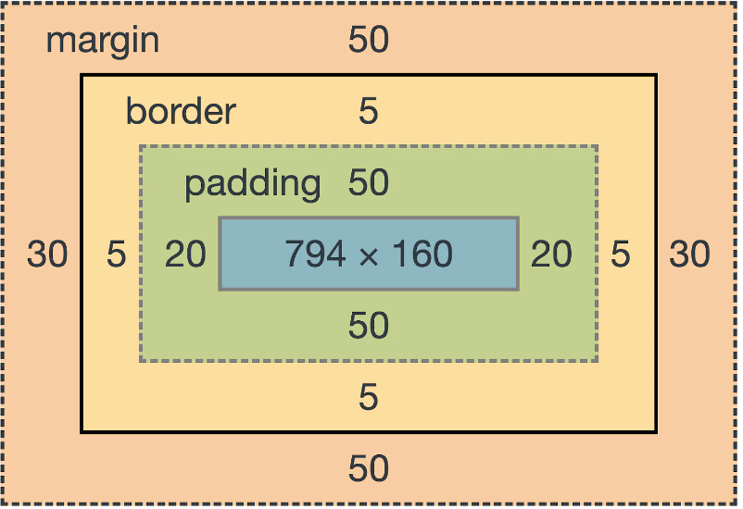

### **Margin**

The margin outer area consists of space between the border and the margin.

If we add margin to a div then the size of the div doesn’t modified.

### **Border**

The border area surrounds the padding and the content, and can be applied to all the sides of the box or to selected side(s) - top, right, bottom, and/or left.

### **Padding**

The padding area is the space around the content area and within the border-box. It can be applied to all sides of the box or to the specific, selected side(s) - top, right, bottom, and/or left.

### **Content**

The content area consists of content like image, text, or other forms of media content. The height and width properties help to modify the box dimensions.

1. **Javascript Task**
2. **List down ways in which JavaScript command can be added to a webpage, what is the preferred way.**

There are typically three ways to add JavaScript to a web page:

1. Embedding the JavaScript code between a pair of <script> and </script> tag.
2. JavaScript code into a separate file with a .js extension, and then call that file in your document through the “src” attribute of the <script> tag, like this: <script src=”app.js”></script>
3. Placing the Javascript code inline - JavaScript code inline by inserting it directly inside the HTML tag using the special tag attributes such as onclick, onmouseover, onkeypress, onload, etc.

Making the separate Javascript code file is the most preferred way to add javascript code to your web. Because, makes your website easy to render the javascript file more quicker ans also it is much easier to maintain.